CPE301 – SPRING 2019

Design Assignment 2A

Student Name: Carlos D Zuniga

Student #: 2000783713

Student Email: zunigc2@unlv.nevada.edu

Primary Github address: https://github.com/cdaniel64/blassen/

Directory: https://github.com/cdaniel64/blassen/tree/master/Design%20Assignments/DA2/DA2A

1. **COMPONENTS LIST AND CONNECTION BLOCK DIAGRAM w/ PINS**

Atmega328p and Hitlego Shield

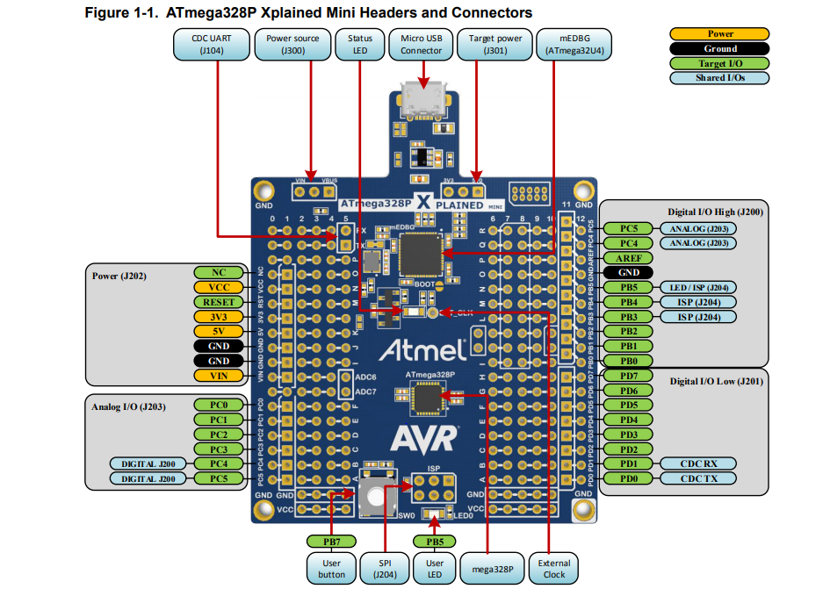 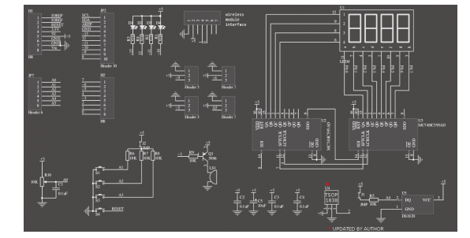

1. **INITIAL/MODIFIED/DEVELOPED CODE OF TASK 1/A**

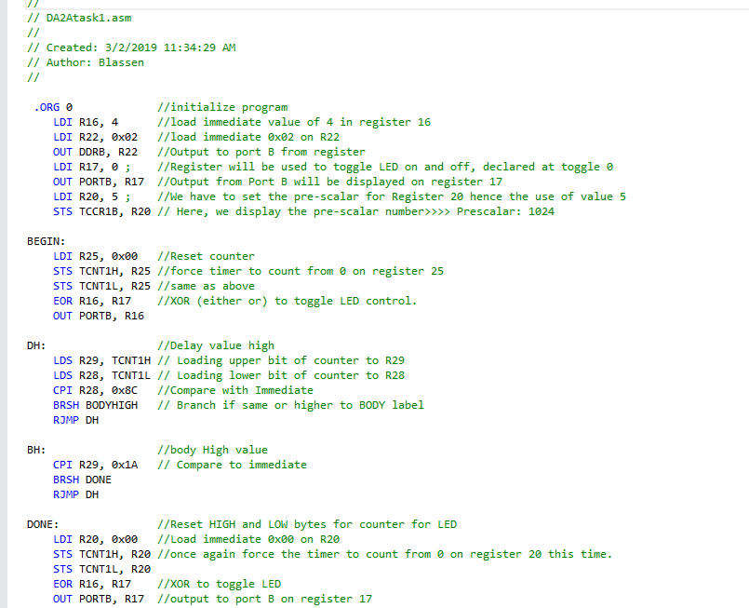

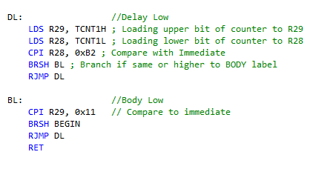

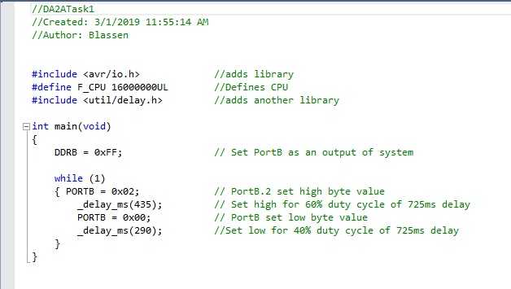

1. **DEVELOPED MODIFIED CODE OF TASK 2/A**

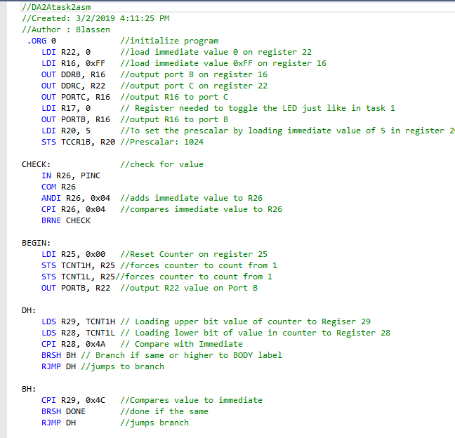

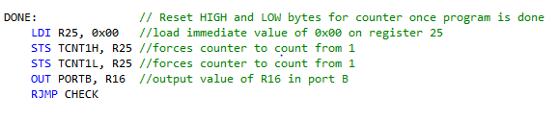

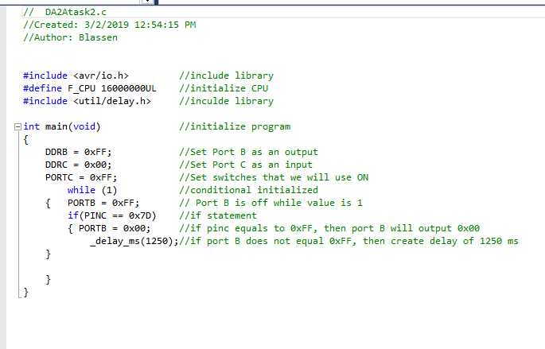

1. **SCHEMATICS**

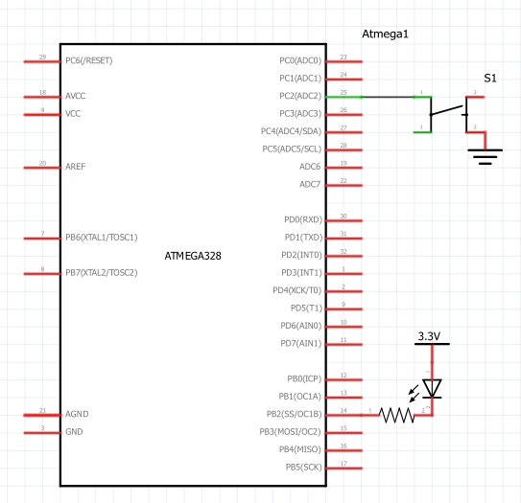

1. **SCREENSHOTS OF EACH TASK OUTPUT on Oscilloscope for further confirmation**

**Task 1 in C duty cycle of 60% (725*.6=435)**

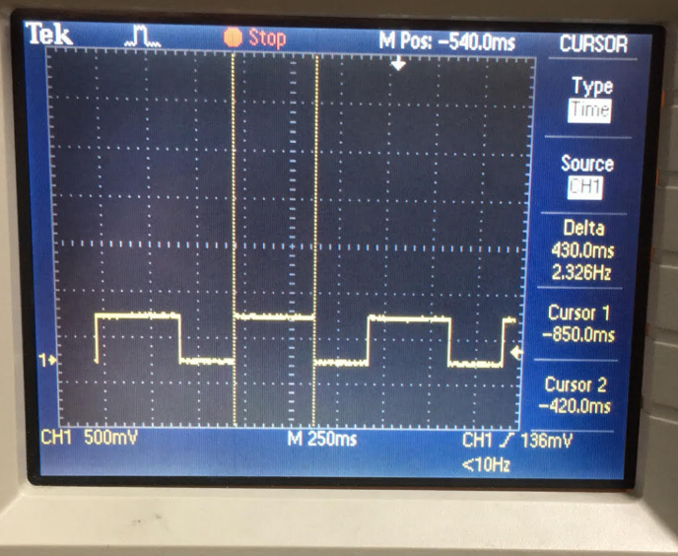

Task 1 in Assembly duty cycle of 60%

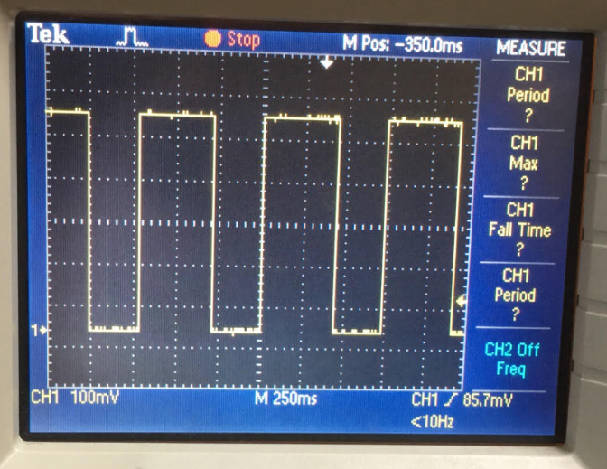

Task 2 in C LED on for 1.25 sec

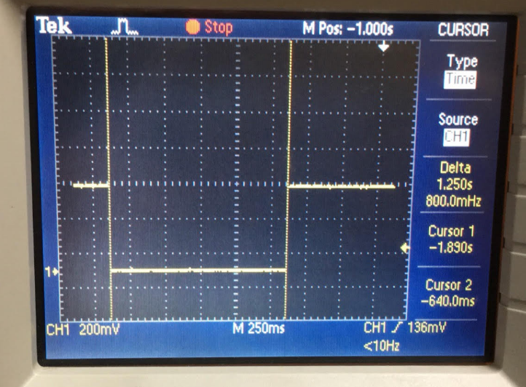

Task 2 in Assembly for LED on for 1.25 sec

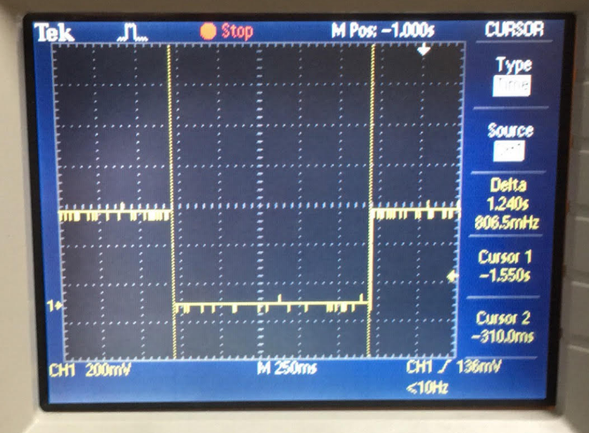

Task 1 in C.

1. **VIDEO LINKS OF EACH DEMO**

Task 1

<https://www.youtube.com/watch?v=EqBQD1HnV40>

Task 2

v <https://www.youtube.com/watch?v=MGmx_rwj9go>

1. **GITHUB LINK OF THIS DA**

<https://github.com/cdaniel64/blassen>

**Student Academic Misconduct Policy**

<http://studentconduct.unlv.edu/misconduct/policy.html>

“This assignment submission is my own, original work”